Insert your centre number, name and candidate number into the header above.
Save this evidence document as evidence_ followed by your centre number_ candidate number. For example: evidence_ zz999_9999
Screenshots or program listings must be copied into appropriate cells in the following table.
Examiners must be able to read the contents including any screenshots without the use of a magnifying glass. Answers that are not readable or missing will not be awarded any marks.
Save this evidence document at regular intervals, for example every 10 minutes.
Question 2
Part 2(a)
#main
import random

#a
ArrayData = [[ 0 for _ in range(10)] for _ in range(10)]
for i in range(10):
for j in range(10):
ArrayData[i][j] = random.randint(1,100)

Part 2(b)(i)
def printArr():
for i in range(10):
row = ""
for j in range(10):
num = str(ArrayData[i][j])
if len(num) == 1:
num = num + " "
row = row + num + " "

print(row.strip())

Part 2(b)(ii)
ArrayLength = 10
for X in range(0, ArrayLength ):
for Y in range(0, ArrayLength - 1):
for Z in range(0, ArrayLength - Y - 1):
if ArrayData[X][Z] > ArrayData[X][Z+1]:
TempValue = ArrayData[X][Z]
ArrayData[X][Z] = ArrayData[X][Z+1]
ArrayData[X][Z+1] = TempValue

Part 2(b)(iii)
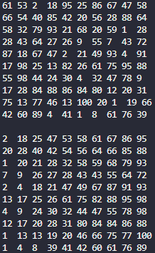

Part 2(c)(i)
def BinarySearch(SearchArray, Lower, Upper, SearchValue):
if Upper >= Lower:
Mid = (Lower + (Upper -1))//2
if SearchArray[0][Mid] == SearchValue:
return Mid
else:
if SearchArray[0][Mid] > SearchValue:
return BinarySearch(SearchArray, Lower, Mid-1, SearchValue)
else:
return BinarySearch(SearchArray, Mid+1, Upper, SearchValue)

return -1

Part 2(c)(ii)

